**Assignment 2**

**DSA0156-Object oriented programming**

**C++ Gaming**

**Parthibhan R**

**192224275**

1. **C++ Program to Find All Roots of a Quadratic Equation**

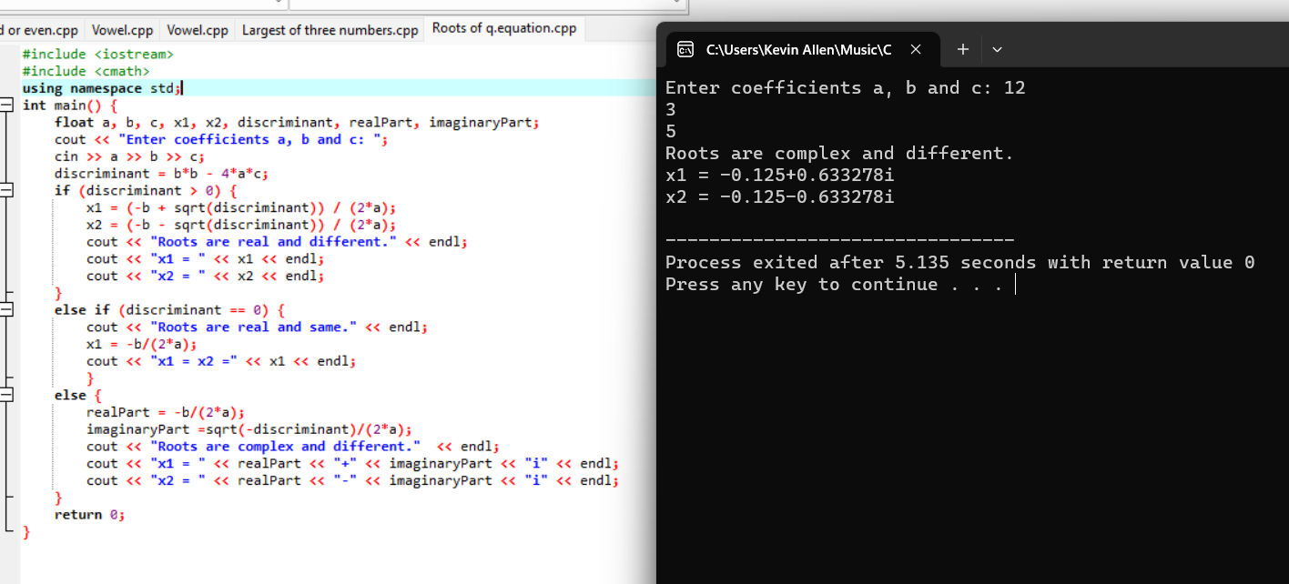

1. **C++ Program to Calculate Sum of Natural Numbers**

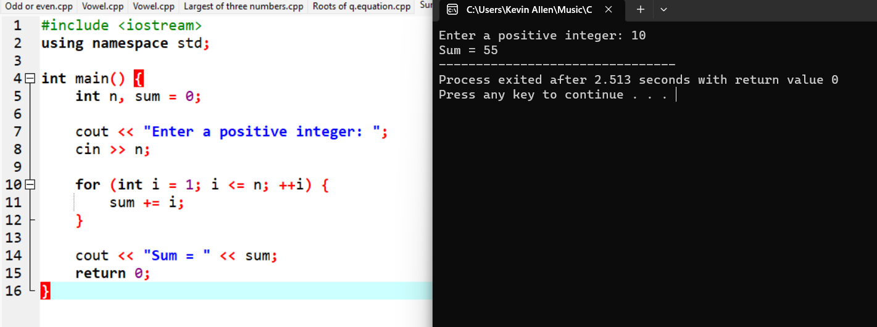

**3.C++ Program to Check Leap Year**

